**Task-1:** Create docker containers for all these components manually using **docker run** command and make the stack working into your **local workstation/laptop/VM**

**Solution:**

**Note:** The Task 1 is done in my local workstation/laptop.

* 1. **Deploying the code base for the python flask application in the local:**

**Installing the dependency module:**

> psycopg2 & redis

Pull the required PostgreSQL Database:

> docker images – Docker images for the redis and postgres is created.

**1.2) Creating a network for the python flask application stack:**

> docker run -d --name db --network flask_network -e POSTGRES_USER=postgres -e POSTGRES_PASSWORD=password -e POSTGRES_DB=mydb -v pgdata:/var/lib/postgresql/data -p 5432:5432 postgres:13 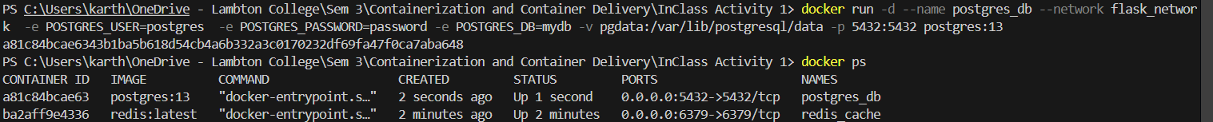

**a) Creating the databae and tables in Postgres:**

> docker exec -it postgresCont bash

**b) Connect to a PostgreSQL Database Server:**

> psql -h localhost -U postgres

**c) Creating table in DB**

> CREATE TABLE users (ID INT PRIMARY KEY NOT NULL, NAME TEXT NOT NULL);

**d) Insert Records into a Postgres Table**

> INSERT INTO tech_authors VALUES (1, 'Laiba');

**1.3) Dockerizing the Python Flask Application:**

> docker build -t flask-application . 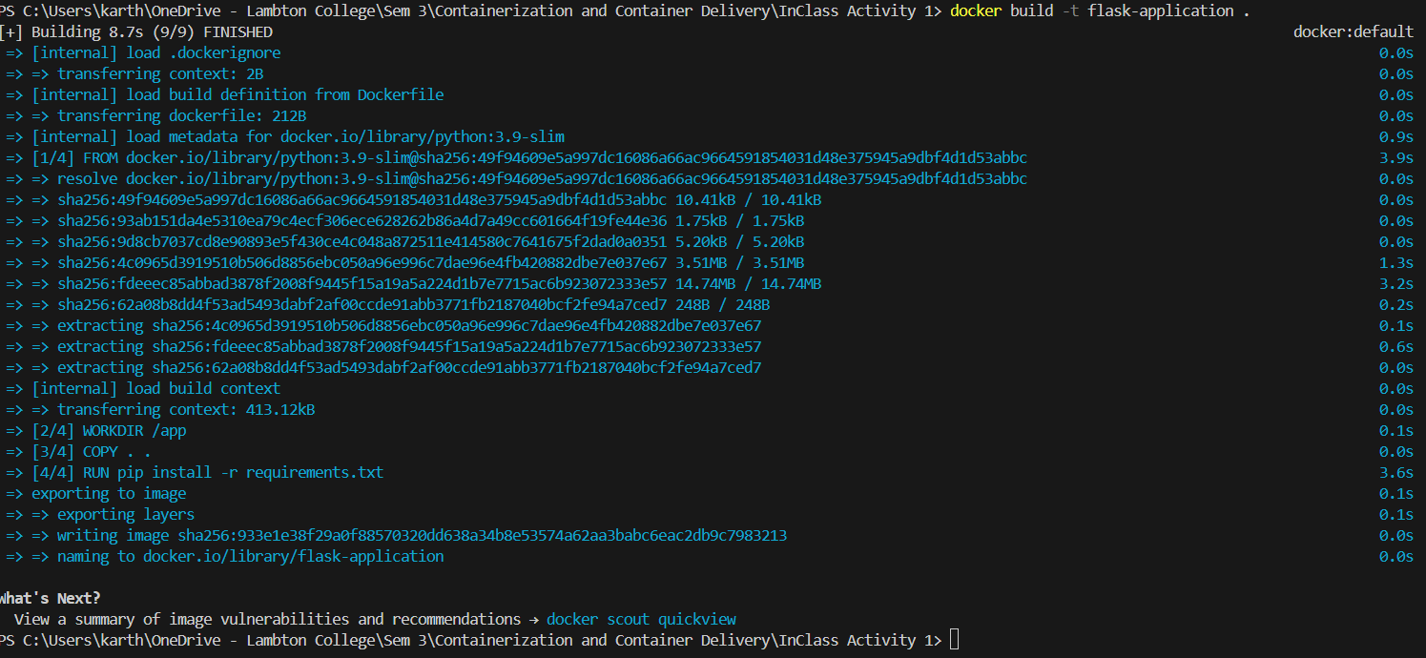

> docker run --name flask_application --network flask_network -d -p 5000:5000 flask-application

> docker images – Flask application image created.

> docker ps

**Task-2:** On a **different host**(VM), deploy the stack using **docker compose**. You should reuse the images you will be creating in task-1

**Solution:**

**Note:** Task 2 is done in Vagrant VM

**2.1) Tagging and Pushing Image into my personal docker repository:**

**1) Flask Application**

> docker image tag flask-app karthik8898/flaskapplication

> docker push karthik8898/flaskapplication

**2) Redis Container**

> docker image tag redis karthik8898/redis

> docker push karthik8898/redis

**3) Modified Postgres_DB**

> docker image tag redis karthik8898/db

> docker push karthik8898/db

**2.2) Creating Docker-compose.yml file to run the application stack in the VM:**

**Docker-compose.yml file**



> docker-compose up -d

> docker ps 

Flask application accessible from the VM using docker-compose: 

Postgres DB accessible from the VM using docker-compose:

